
Appendix VII: Supervisor Evaluation of Intern
Student Name: ____________________________________________ Date: ____________________
Name of Internship Supervisor: Swati Kulkarni Title: Senior Associate – Business HR
Organization: Opus Technologies
Internship Organization Address: Floor 1, Building No: 04, Commerzone, Samrat Ashoka Path, Off Airport Road, Yerwada, Pune, Maharashtra 411006, India.
Date of Internship: From 09/02/2026 To 29/05/2026
Please evaluate intern by indicating the frequency with which you observed the following behaviors:
Parameters | Needs Improvement | Satisfactory | Good | Excellent
Behaviors
Performs in a dependable manner
Cooperates with co-workers and supervisors
Shows interest in work
Learns quickly
Shows initiative
Produces high quality work
Accepts responsibility
Accepts criticism
Demonstrates organizational skills
Uses technical knowledge and expertise
Shows good judgment
Demonstrates creativity / originality
Analyzes problems effectively
Is self-reliant
Communicates well
Writes effectively
Has a professional attitude
Gives a professional appearance
Is punctual
Uses time effectively
Overall performance of student intern (Circle one): Needs improvement / Good / Excellent
Additional comments, if any:____________________________________________________________
____________________________________________________________________________________
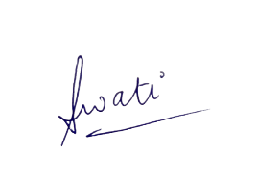
Signature of Industry Internship Supervisor: Mentor Name
Signature of HR Manager: Swati Kulkarni

